|  |  |
| --- | --- |
|  |  |

**Faculty of Technology and Engineering**

**Chandubhai S. Patel Institute of Technology (CSPIT)**

**Department of Computer Science & Engineering**

Date: / /

**Laboratory Manual**

|  |  |  |  |  |  |
| --- | --- | --- | --- | --- | --- |
| Academic Year | : | 2024-25 | Semester | : | 4 |
| Course code | : | CSE206 | Course name | : | DATABASE MANAGEMENT SYSTEM |

|  |
| --- |
| **Practical - 6** |
| * **Aim: -** You are a database administrator for a manufacturing and consulting company. The company maintains two primary tables: Product and Employee Company (emp_company). You are tasked with solving business queries related to order quantities, employee salaries, and company analysis using SQL grouping and aggregate functions. To manipulate and retrieve meaningful insights using grouping and aggregate functions in SQL while adhering to database constraints and integrity rules.   **Constraints –**   * **Not Null Constraints:** Critical fields such as product numbers, employee names, and salaries must not contain null values. * **Unique** **Constraints**: Ensure the integrity of unique fields like Product_no and ENAME. * **Check Constraints:** Validate that quantities and salaries have valid positive values.  1. **Product Table**: Tracks order details for various products.    * Detorder_no (Primary Key)    * Product_no (Not Null, Unique)    * Qty_order (Not Null, Check: Greater than zero) 2. **emp_company Table**: Tracks employees, their companies, and salaries.    * ENAME (Not Null, Unique)    * CNAME (Not Null)    * SALARY (Not Null, Check: Greater than zero) |

**Tasks:-**

The logistics department has provided the following product order details to be inserted into the Product table:

1. **Insert Values**:

* Insert the above data into the Product table.

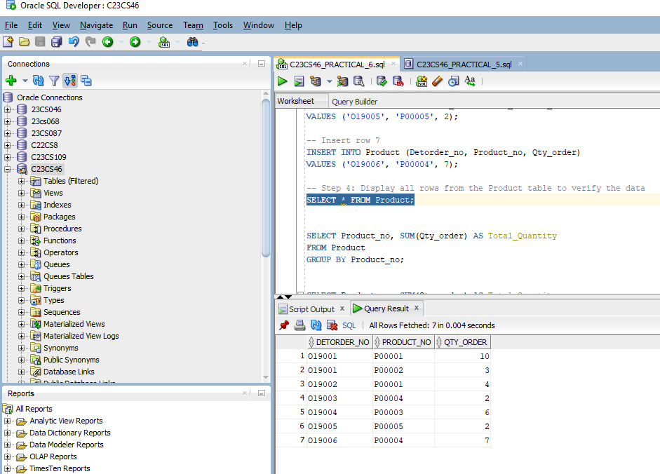

1. **Total Quantity per Product:**

* Retrieve the product numbers and total quantities ordered for each product.

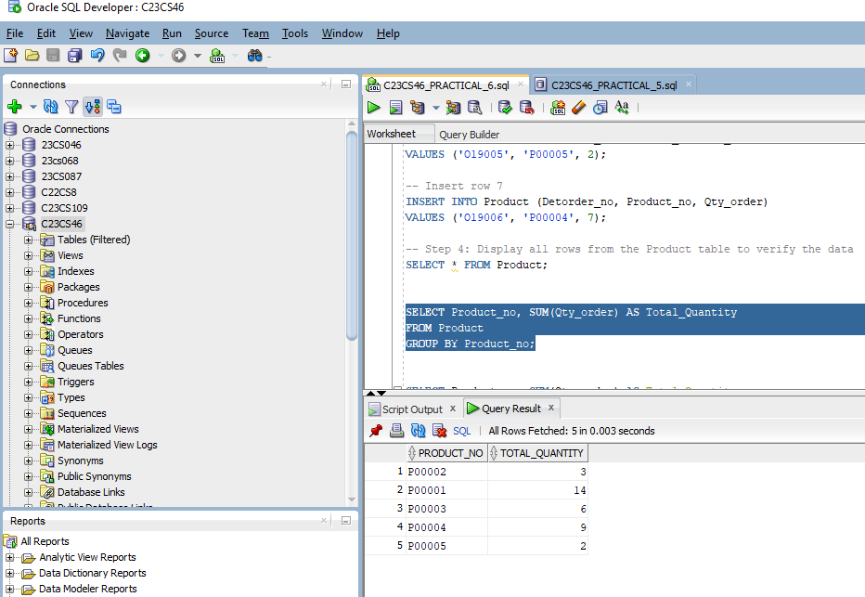

1. **Filter Specific Products:**

* Retrieve the product numbers and total quantities ordered for products P00001 and P00004.

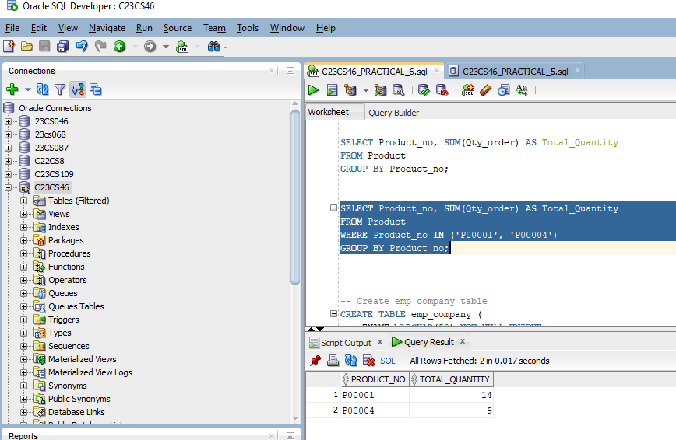

The HR department has provided the following employee data to be inserted into the emp_company table:

1. **Insert Values:**

* Insert the above data into the emp_company table.

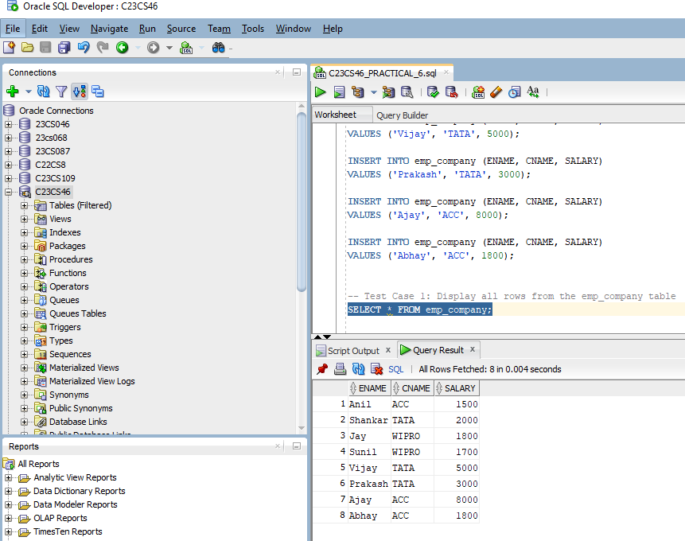

1. **Maximum Salary per Company:**

* List the company names and the maximum salary in each company .

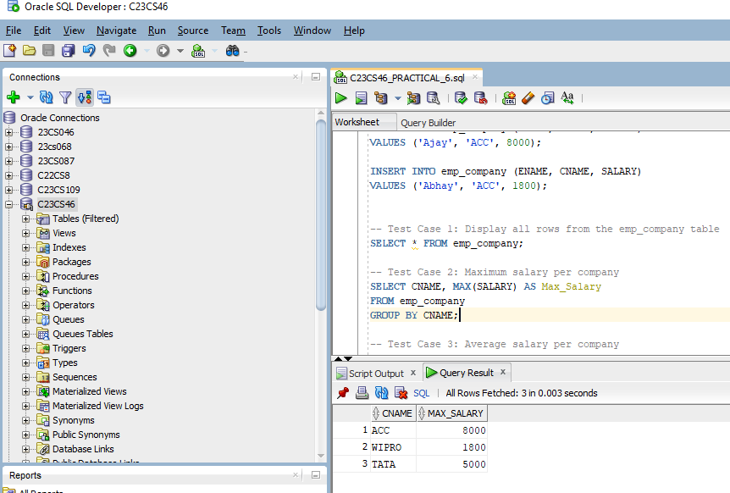

1. **Average Salary per Company:**

* Calculate the average salary for each company.

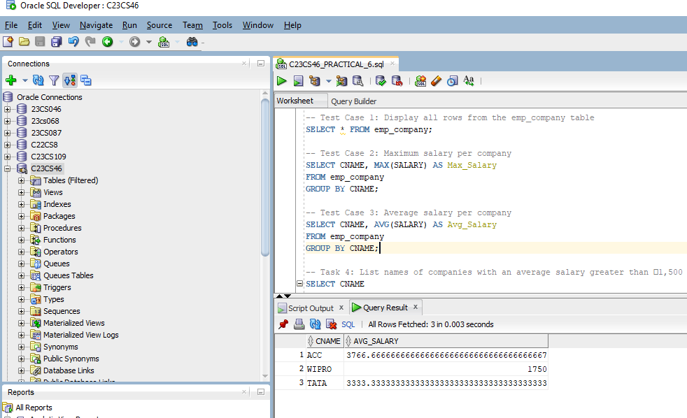

1. **Filter Companies by Average Salary:**

* List the names of companies with an average salary greater than ₹1,500.

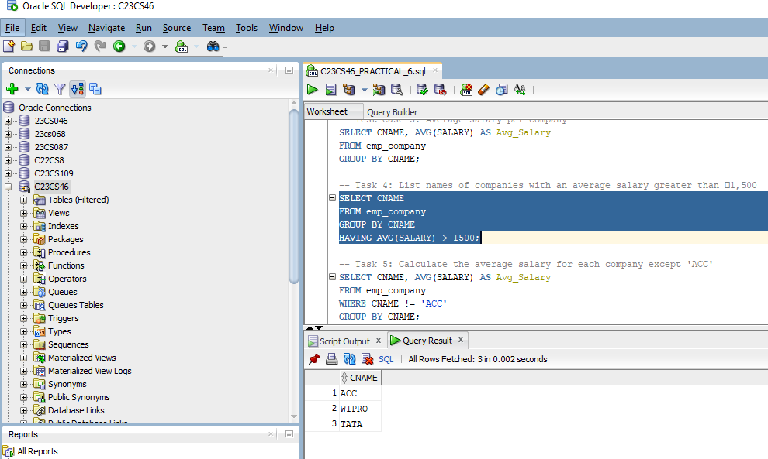

1. **Exclude a Specific Company:**

* Calculate the average salary for each company except ACC.

